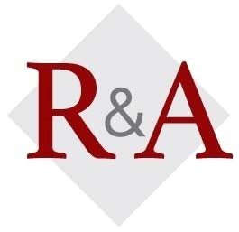

***"Your Best Resource for Property Tax Relief”***

**2017 Free 1-Hour Property Tax Appeal Sessions**

**Raila & Associates, P.C. offers free tax info sessions that teach you how to lower your tax bill, get proper tax exemptions, tax refunds, understand market value reassessment notices and use self-help governmental websites. Every year we partner with the Federal Reserve Bank of Chicago for Money Smart Week.**

**Visit MoneySmartWeek.org or TaxesTooHigh.com for property tax info or other sessions.**

|  |  |  |  |  |
| --- | --- | --- | --- | --- |
|  | **Saturday, April 22** |  |  | **Tuesday, April 25** |
| ***Time:*** | 9:30 AM |  | ***Time:*** | 11:30 AM |

***Sponsor:*** Rogers Park Public Library ***Sponsor:*** Morton Grove Public Library

6907 N. Clark St, Chicago

6140 Lincoln Ave, Morton Grove

***Contact:*** Jacqueline Hui ***Contact:*** Bob Palas

312-744-0156 847-929-5122

|  |  |  |  |  |
| --- | --- | --- | --- | --- |
|  | **Thursday, April 27** |  |  | **Saturday, April 29** |
| ***Time:*** | 6:30 PM |  | ***Time:*** | 10:00 AM |

***Sponsor:*** Niles Public Library ***Sponsor:*** Edgebrook Public Library

6960 W Oakton, Niles

5331 W. Devon, Chicago

***Contact:*** Judy McNulty ***Contact:*** Jenny Reynolds

847-663-6431 312-744-8313



|  |  |  |  |  |
| --- | --- | --- | --- | --- |
|  | **Saturday, April 29** |  |  | **Tuesday, May 16** |
| ***Time:*** | 2:00 PM |  | ***Time:*** | 7:30 PM |

***Sponsor:*** Sulzer Public Library ***Sponsor:*** Mt. Prospect Public Library

4455 N Lincoln, Chicago

10 S Emerson, Mt Prospect

***Contact:*** Brent Lipinski ***Contact:*** Marcy Berger

312-744-2575 847-253-5675